

In Loving Memory
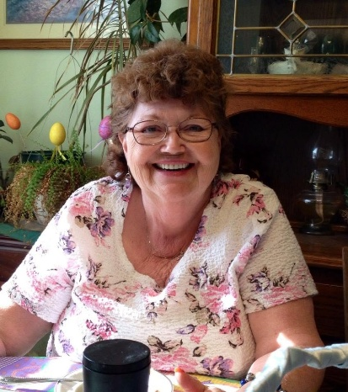
Sharon Leona Allen
April 6,1952 ~ June 24, 2026

"Though he brings grief, he will show
compassion, so great is his unfailing love."
Lamentations 3:32

With heavy hearts, the family announces Sharie (Walters) Allen, age 74, passed away unexpectedly at her Lake Village home on Wednesday, June 24, 2026. She was born April 6,1952 in South Holland, Illinois to Lloyd and Edna (Cox) Walters. She was a 1970 graduate of North Newton High School in Morocco, Indiana and held several jobs over the years including selling Artex, Amway, and Tiara and a Special Needs Caregiver. But her first, and longest-lasting, career was as a waitress. She started at her parents' restaurant as a teen and worked several places over her lifetime. The most prevailing was working for Larry Carroll for many years, first at Larry's Tap in Thayer, then at his restaurant in Roselawn until its closing.
Sharie was active in 4-H as a youth. A longtime member of the American Legion Auxiliary (currently Kouts unit #301), she held many offices and chair positions over the years. She was very social and enjoyed Bowling, Bingo, Bunco, and Darts. At home, she enjoyed her flower garden and watching her birds. She loved her dogs and always had several in her home. She loved angels, roses, the color purple and all things Betty Boop.
Sharie was spunky, sassy, funny and well-liked/loved by all who knew her. She was often determined when it came to how she wanted things but would always be there for family and friends.

Sharie was preceded in death by: Parents, Lloyd and Edna (Cox)Walters;
husband, Frederick Allen; her sister, Sindi Walters; and a niece, Amber Walters
Survived by her children: Lisa (Fred) Burke and Scott Shultz; Grandchildren: Schuyler Gargano,
Alton (Sarah) Brown, Jr, and River Shultz; Brother: Schuyler (Teresa) Walters;
Nieces/Nephews: Spring Gonzales, Hope Nunn, Schuyler N. Walters;
and 2 Great-granddaughters, Adalynn and Athena Brown
A Celebration of Life, led by Pastor Joel Gilbert, will be held on Saturday, July 11, 2026,
at Redeemer Church 5417 E SR 10 in DeMotte (Roselawn), Indiana at Noon. All family and
friends are welcome to join in a meal at the church immediately following the service.
The family thanks relatives, friends, neighbors, and Redeemer Church
for their prayers, visits, meals, and support. Special thanks to Sharie's best friend,
Nancy, for her presence, love and support of Sharie then, now, and always.

